**SMART HOME**

**INTRODUCTION:**

This is an ardunio based detection microsever are used in it PIR SENSOR are used when enemy are enter inside the home PIR SENSOR detect it and the buzzer make sound and the door are authomatically closed the door and the led are blow

**CODE:**

#include<Servo.h>

Servo s;

void setup()

{

s.attach(3);

Serial.begin(9600);

pinMode(4,INPUT);

pinMode(12,OUTPUT);

}

void loop()

{

int p=digitalRead(4);

Serial.println(p);

digitalWrite(13,LOW);

s.write(0);

delay(2000);

if(p)

{

delay(1000);

Serial.println("Movement Found");

tone(12,20);

delay(1000);

digitalWrite(13,HIGH);

if ("Movement Found")

{

s.write(0);

delay(1000);

s.write(15);

delay(1000);

s.write(24);

delay(1000);

s.write(75);

delay(1000);

s.write(115);

delay(1000);

s.write(235);

delay(1000);

}

}

delay(1000);

}

**FIGURE:**

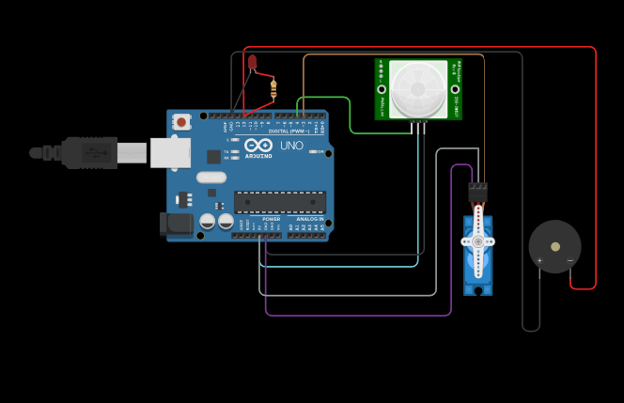

**TINKERCAD LINK:**

<https://www.tinkercad.com/things/batYYa4AmZa>

**SUBMITTED BY:**

SHUMIN RAKESH RU

DEPARTMENT OF ECE

961819106049